https://app.pluralsight.com/profile/author/erik-dahl👍
https://app.pluralsight.com/courses/6bf2a779-cb05-4e71-be9e-af82075fc09b/table-of-contents

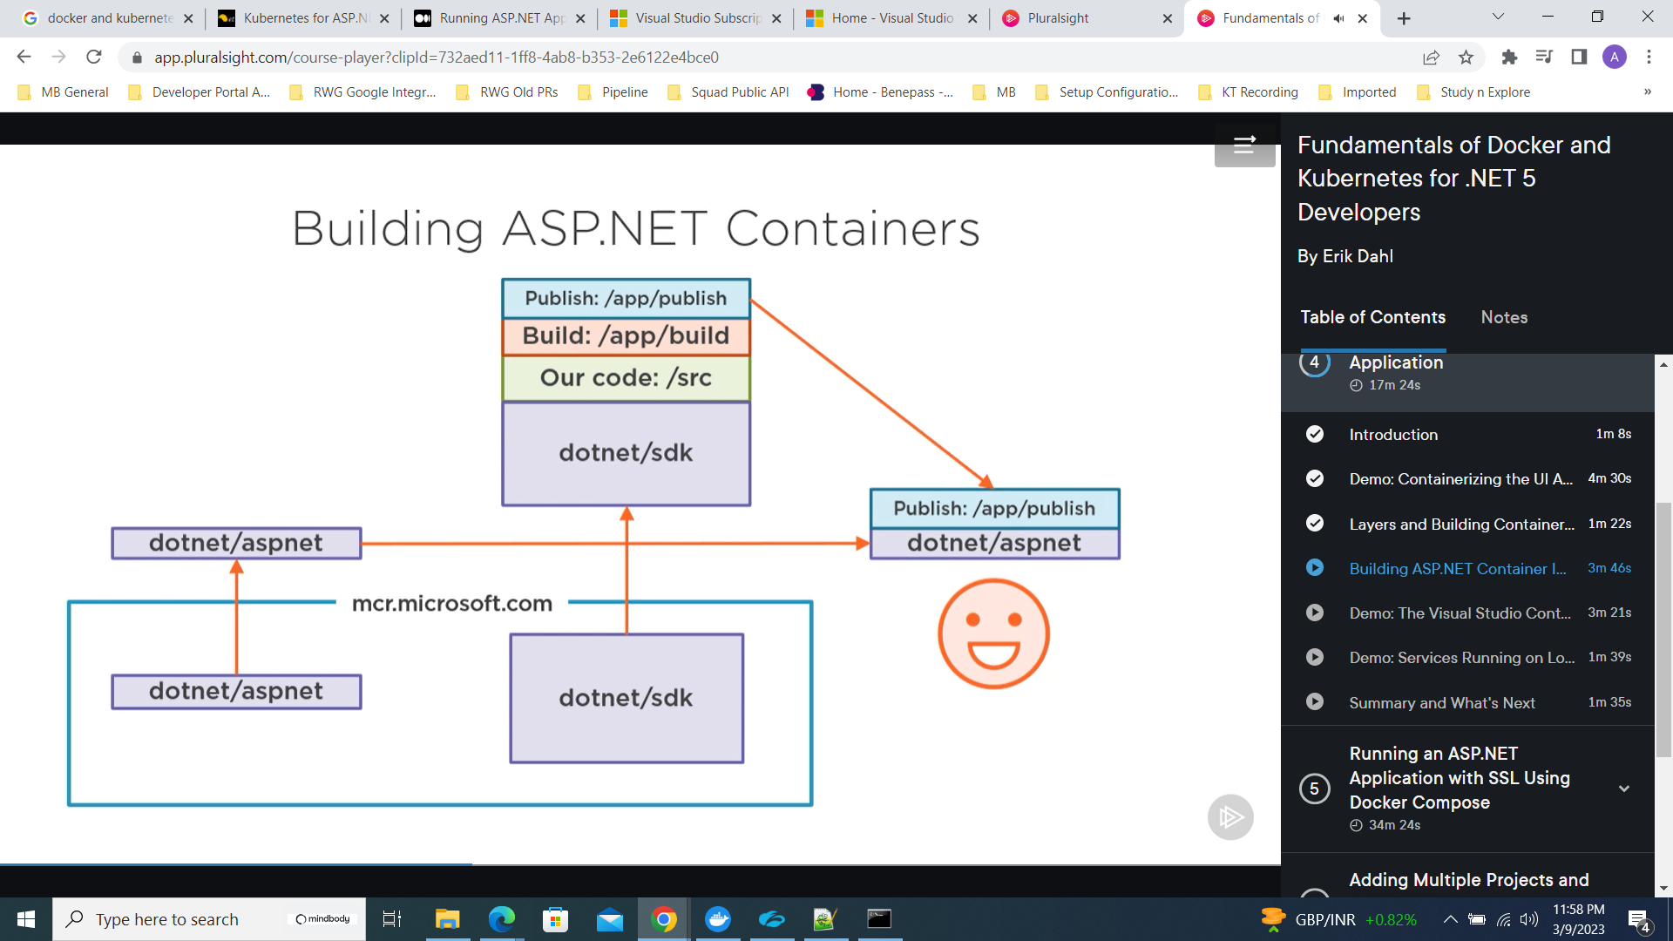

Multistage docker file
